Bondar Agatha
The pupil of the 9-th form
Gymnasium 9
Grodno,Belarus
Teacher: Mitskevich Alexandra Michailovna

IS the

TIME FOR
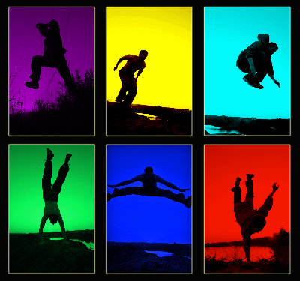
sport
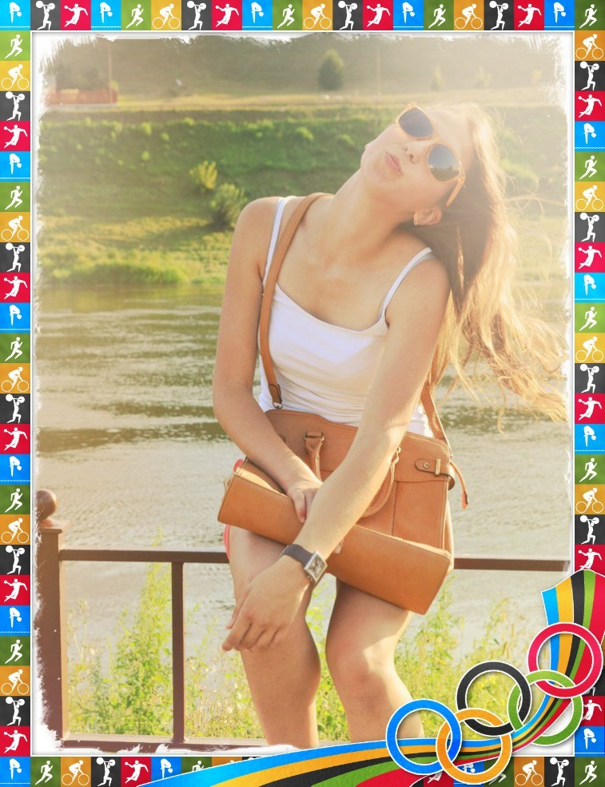
hi, there! I’m Agatha from Belarus. Don’t worry, I’m not an Olympic champion, but I want to prove that you don’t have to be a professional if you want to keep fit and be cheerful! I’ll show you that now! Attention, please!:)

“Home” variant 1.
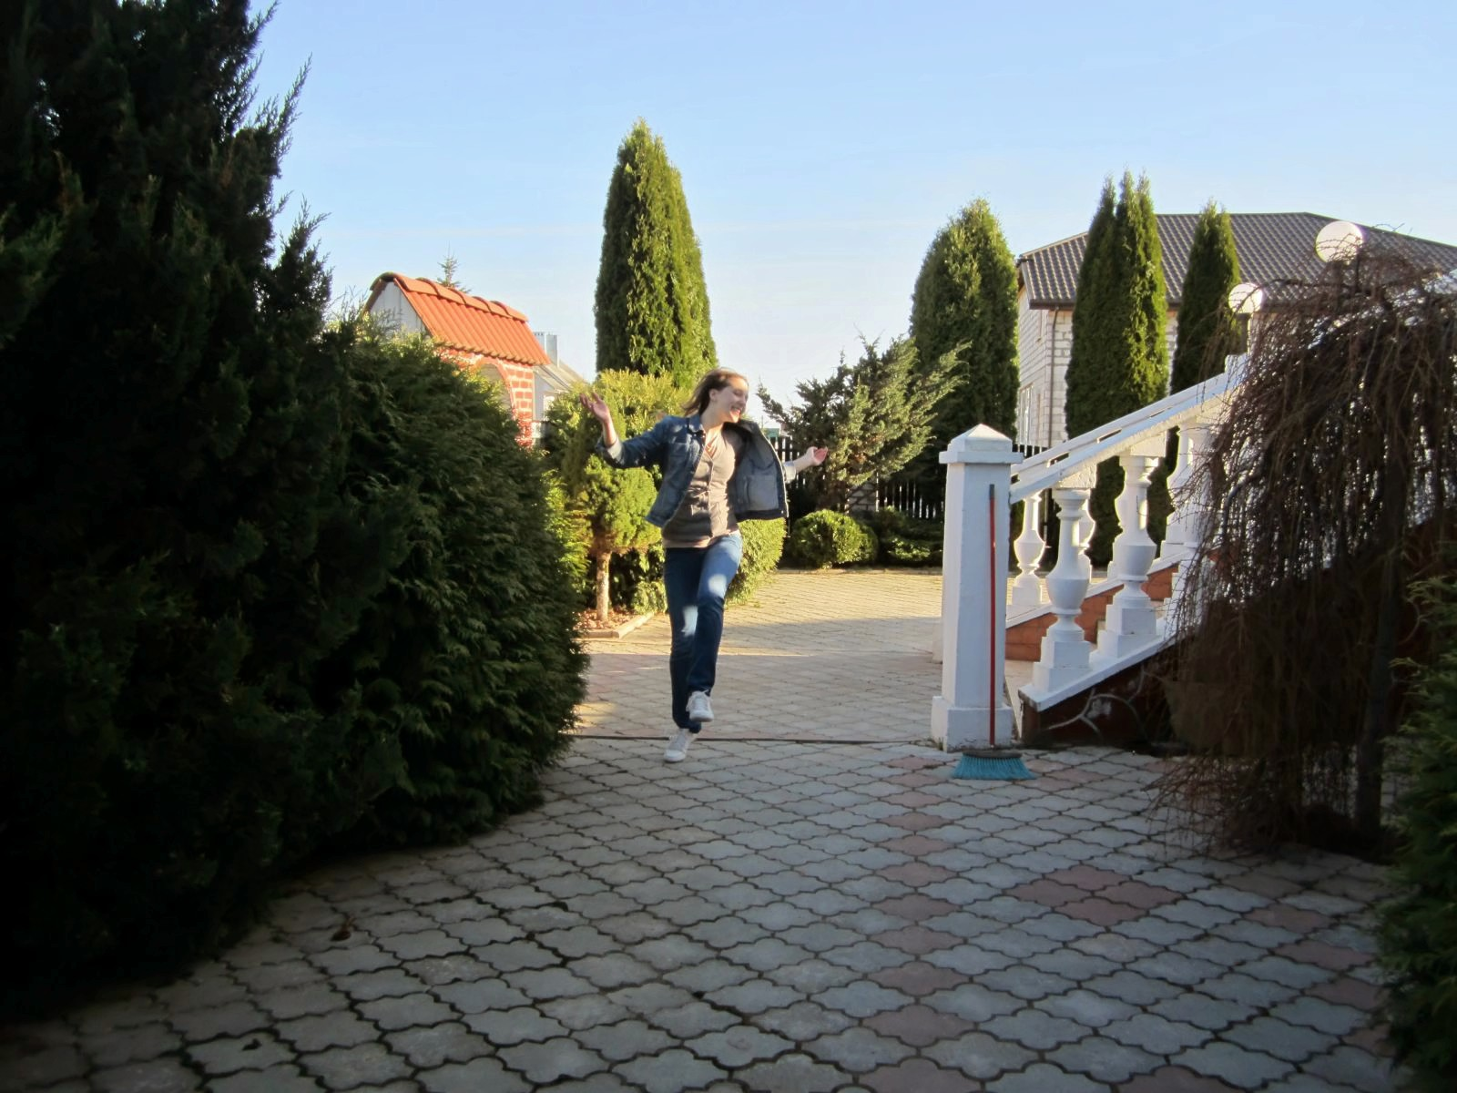
Jogging around the house .
P.S. Do this please, if you live in the house of your own. Otherwise , people will be very surprised watching you)

“Home” variant 2.
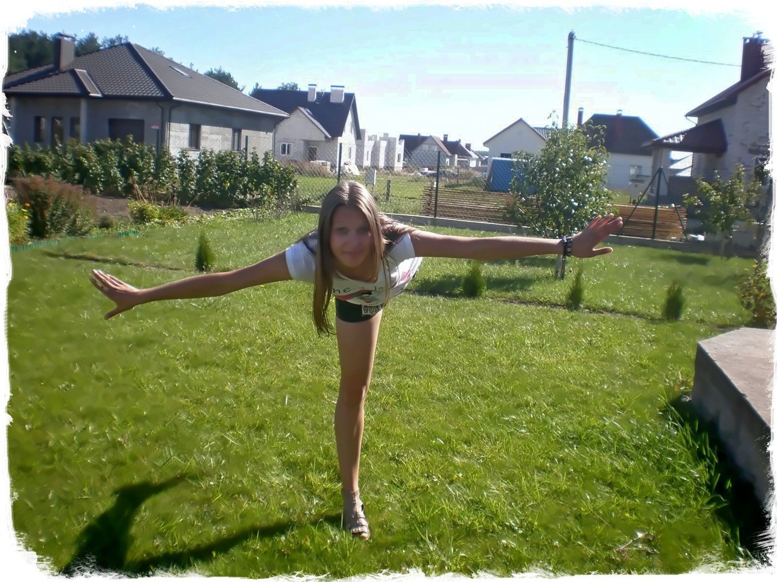
Doing gymnastics on the grass.
P.S. Pretending that you are a swallow remember about the law of gravitation and don’t forget that girls don’t fly)

3. “Pool is cool” variant.
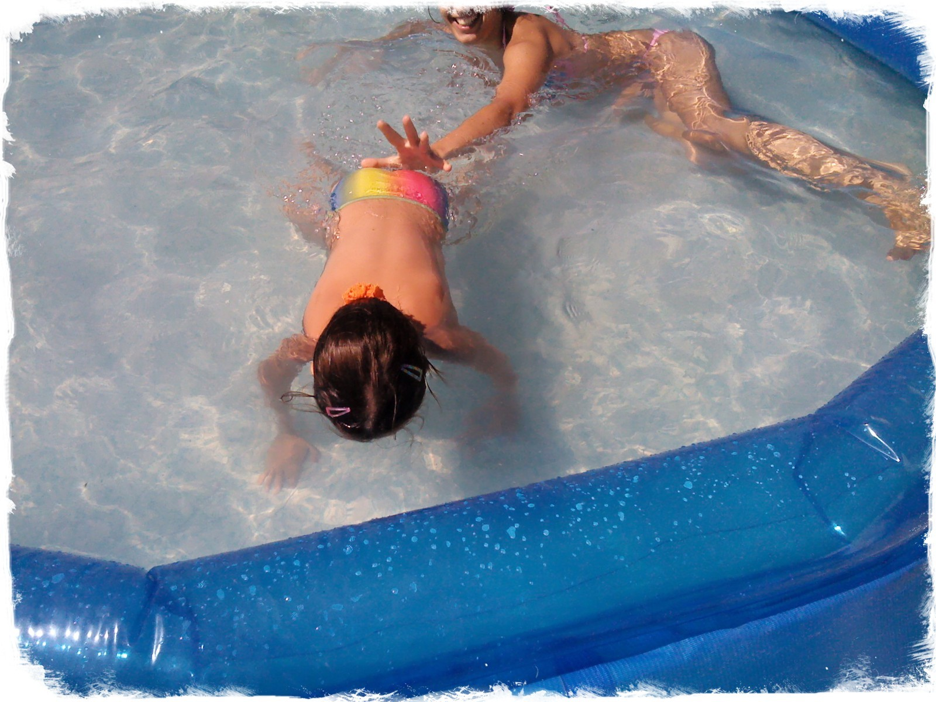
A Swimming pool can serve a nice alternative to seas and lakes.
P.S. In case your swimming style is “doggish”, make sure you can reach the bottom of your pool with your legs. )

4. “In case of rain” variant

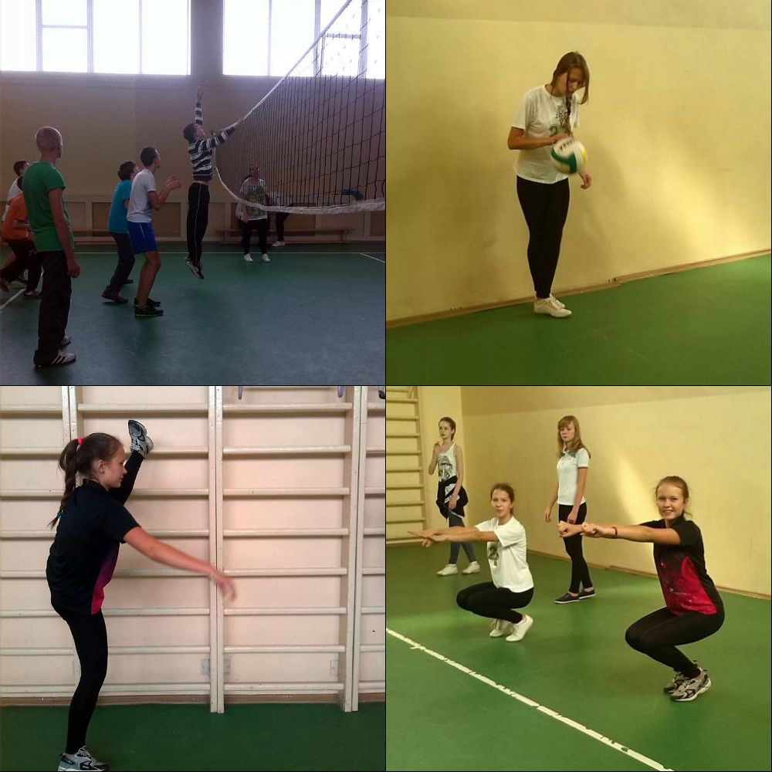

Don’t trouble if the weather outside is not perfect. Having fun with your friends in the gym will bring you much joy and delight!
P.S. playing team sports try not to win the boys all the times. That will make them feel small and sad.
5. “Shopoholics” variant.
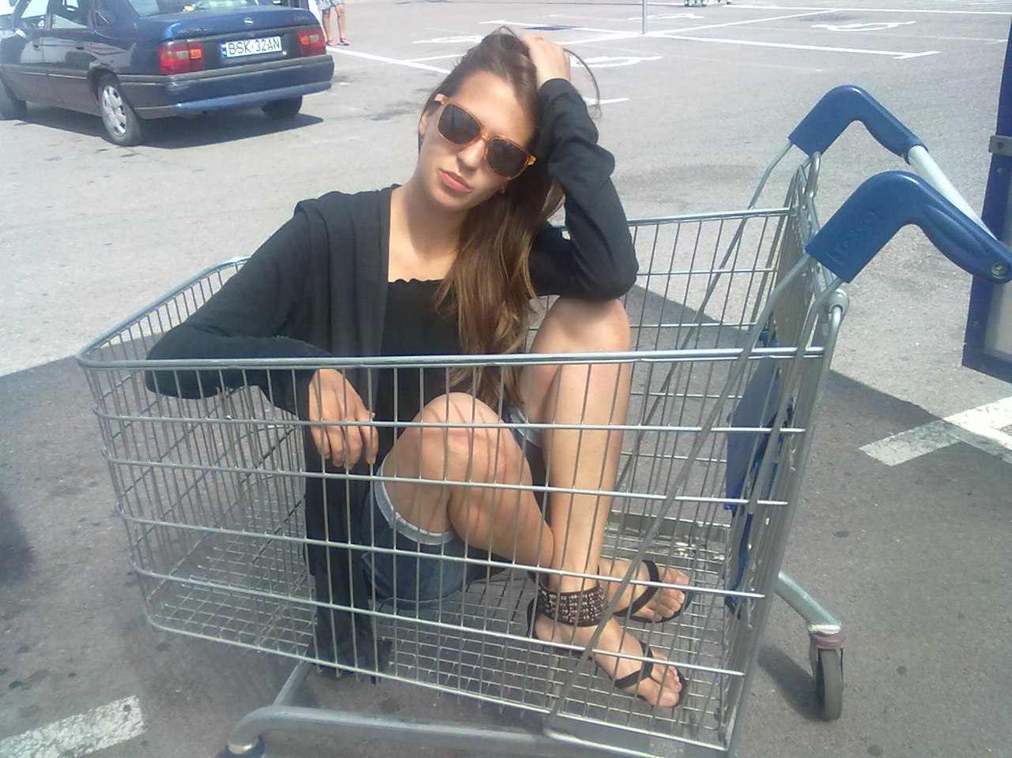
If you are tired after having a long-lasting shopping day with you parents, try “shopping carting”
All you have to do is to put yourself and your Mum in separate carts and ask your Dad and siblings to push and run with them.
P.S. If your Daddy suffers from radiculitis, your race won’t last that long)

6.” Sit and sing” variant.
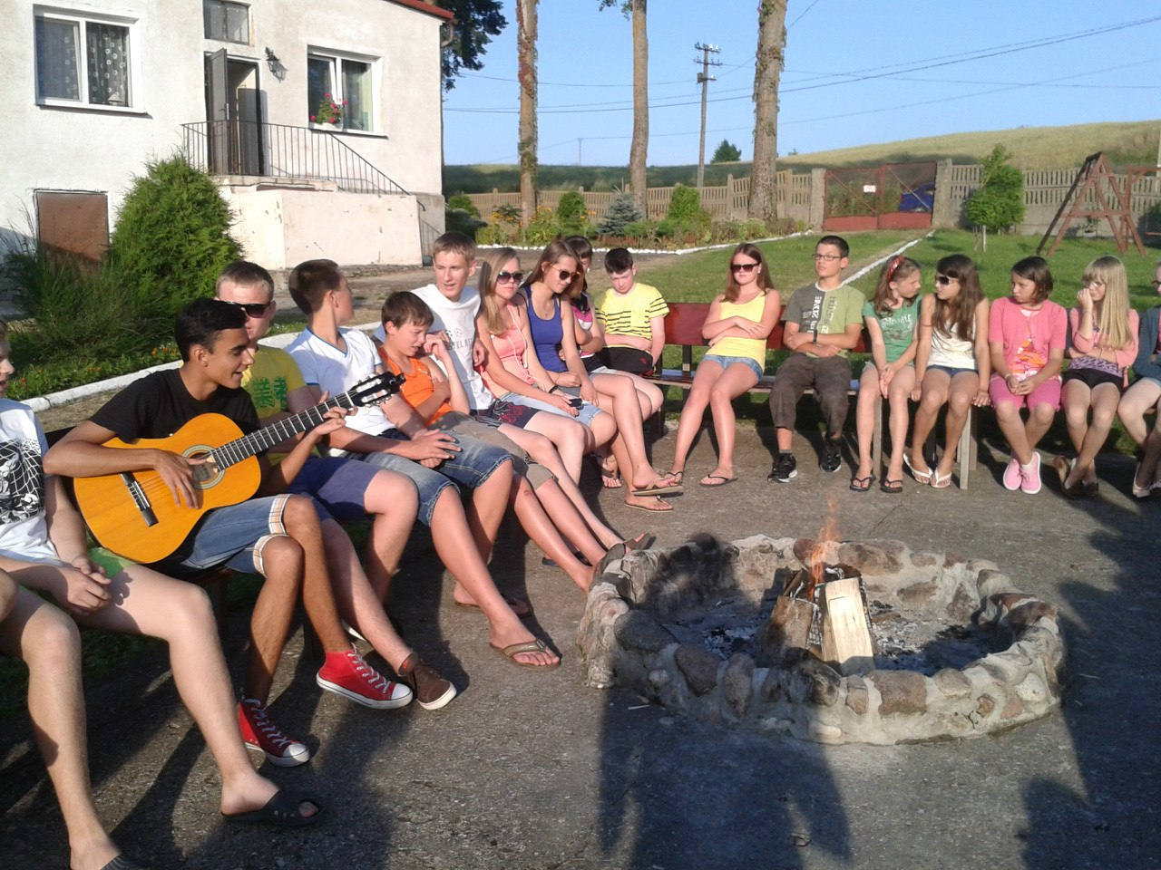
Train you vocal cords by singing in a company.
P.S. Make sure you are not going to sing hardcore or heavy metal songs. Otherwise you need to book a visit to an ENT doctor in advance. Your cords will definitely need it.

I suggested you some sporting ideas. You can follow them or not. But if you do…..
P.S. don’t tell anybody that it was me who advised them) I’m not responsible for all possible consequences.)
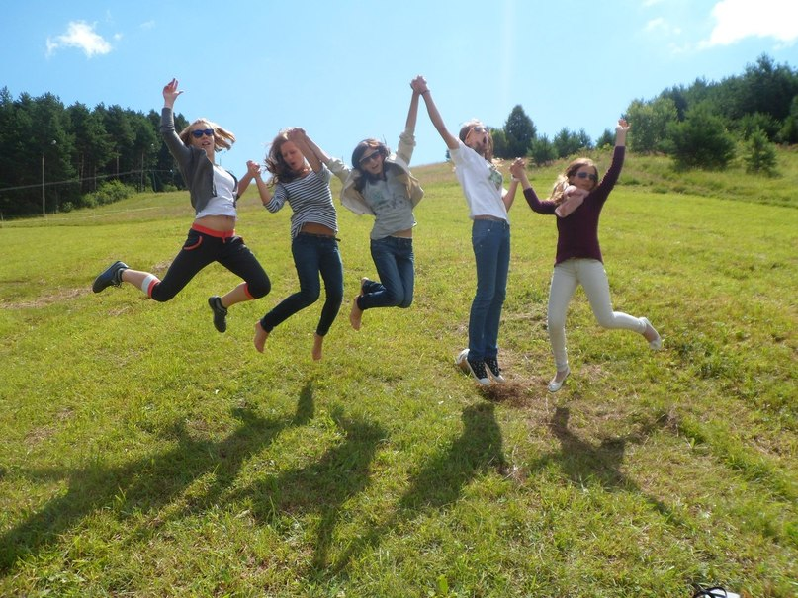

All the rights reserved.

Belarus, Grodno, 2013
- Фотографии взяты из личного архива с разрешения родителей и лиц,присутствующих на фото.
- Картинки взяты с сайтов : http://careers.queensu.ca/students/jobs/summer.html
- http://www.ipad-labs.ru/news/457-luchshie-prilozheniya-2012-goda.html

