C:\Program Files\Microsoft Office\MEDIA\CAGCAT10\j0299763.wmf

SUMMER-

THE BEST TIME FOR SPORT

Леончикова

Вероника Константиновна,

ученица 9 класса КГУ ОШ №2 акимата города Шахтинска, Казахстан

Учитель: Букина Инна Викторовна

C:\Program Files\Microsoft Office\MEDIA\CAGCAT10\j0297551.wmf

SUMMER – THE BEST TIME FOR SPORT

C:\Users\Admin\AppData\Local\Microsoft\Windows\Temporary Internet Files\Content.IE5\07WAC4FG\MC900438153[1].wmf 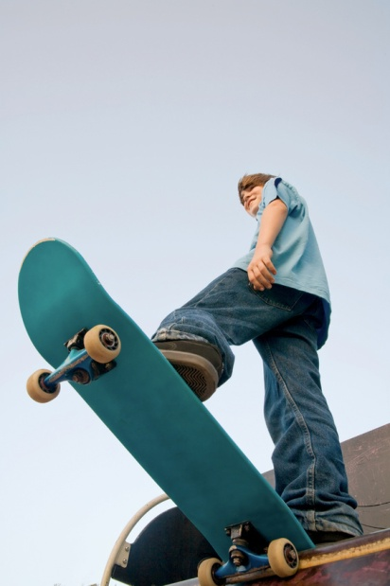

|  |  |
| --- | --- |
| Summer is a good season for rest and sport combination. It is possible to play team sports games. I do sports on my personal initiative. In summer I went in for cycling, rollerblading, skateboarding, swimming in swimming pools and in small rivers. Tennis, volleyball, football …It was super! Every summer I combine rest and sports. |  |

**C:\Users\Admin\AppData\Local\Microsoft\Windows\Temporary Internet Files\Content.IE5\HV1TSY5D\MC900231369[1].wmf**

**One of summer sports is cycling. My parents have bought me bicycle, when I was four years old. Since then I adore cycle riding, and I do it every summer. 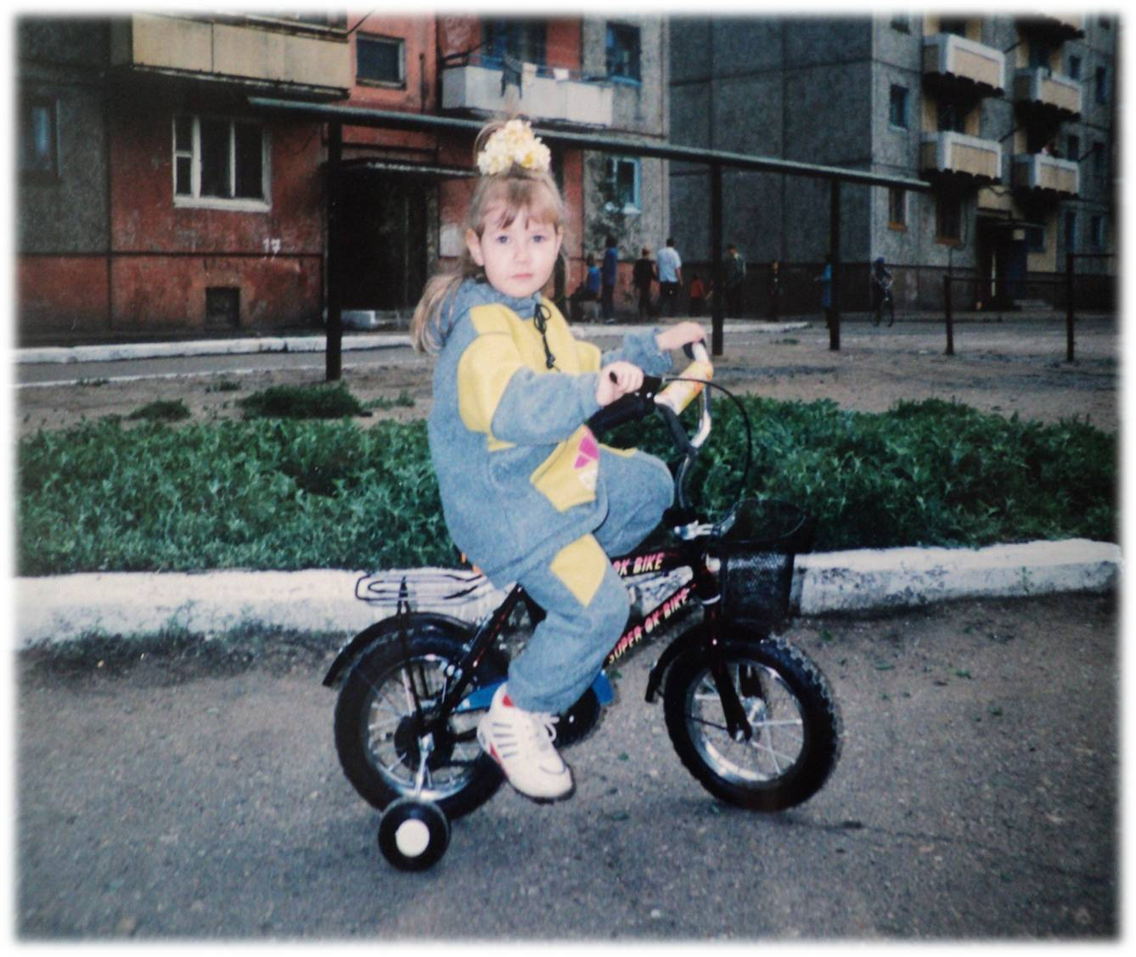The sense of freedom, independence and flight brings me cycling.**

Sunny days! It would not hurt to take a refreshing dip. I liked swimming, so I went to the swimming pool or to small rivers every day. 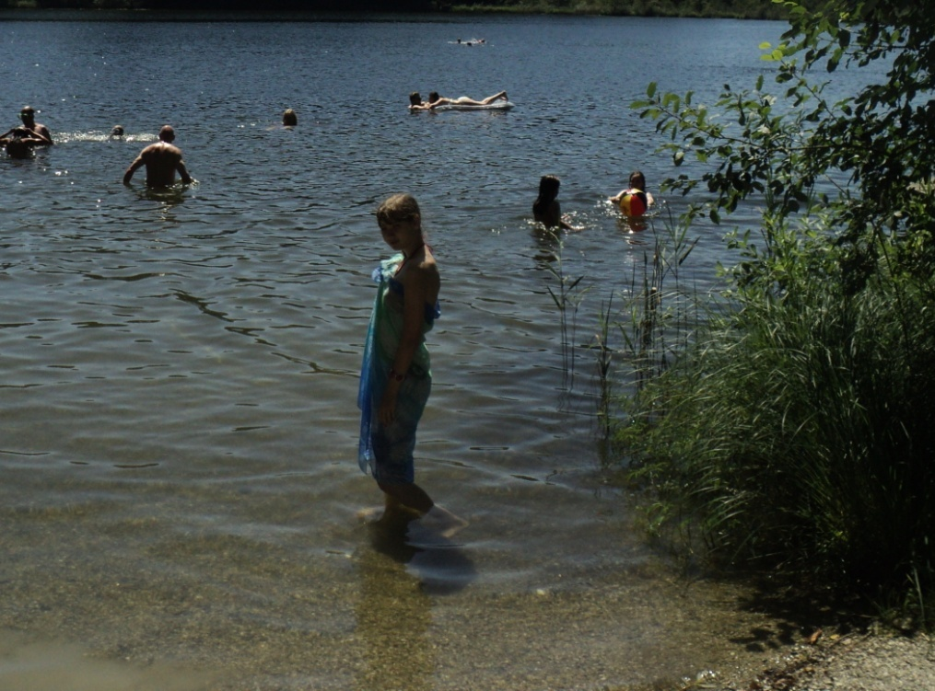

**To sunbathe on the beach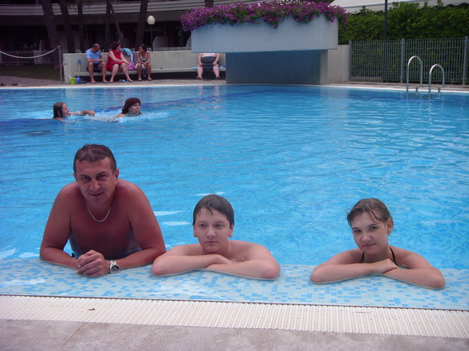 was my favourite occupation. I think swimming and sunbathing are sports! They make me strong, healthy and optimistic.**

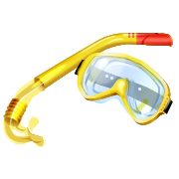

**Not always the weather was hot.**

|  |  |  |  |
| --- | --- | --- | --- |
| **Summer weather brought us surprises.**  **DSC01181.JPGBut it did not disturb to go in for active sports.**  **DSC00254.JPG** |  |  |  |

**In summer we were in Karkaralinsk. There are many high mountains there.**

|  |  |
| --- | --- |
| **I liked climbing** *http://clck.yandex.ru/click/dtype=stred/pid=20/cid=71883/path=page-translation-content.fulltext/*http:/slovari.yandex.kz/%7Ep/%D0%BF%D0%BE%D0%B4%D0%BD%D0%B8%D0%BC%D0%B0%D1%82%D1%8C%D1%81%D1%8F%20%D0%B2%20%D0%B3%D0%BE%D1%80%D1%83/en/* |  |

**the mountains. As for me, climbing the mountains makes hardy.**

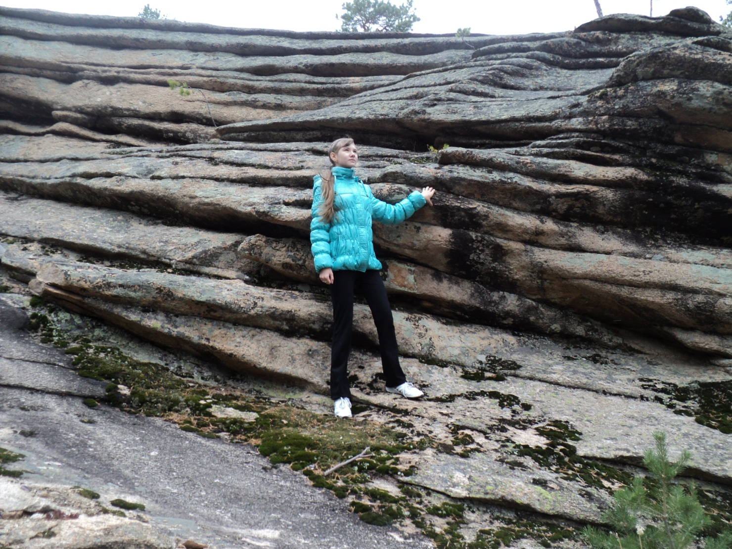

C:\Users\Admin\AppData\Local\Microsoft\Windows\Temporary Internet Files\Content.IE5\KAEDV3L4\MC900435727[1].wmfC:\Users\Admin\AppData\Local\Microsoft\Windows\Temporary Internet Files\Content.IE5\KAEDV3L4\MC900435727[1].wmfC:\Users\Admin\AppData\Local\Microsoft\Windows\Temporary Internet Files\Content.IE5\KAEDV3L4\MC900435727[1].wmfC:\Users\Admin\AppData\Local\Microsoft\Windows\Temporary Internet Files\Content.IE5\KAEDV3L4\MC900435727[1].wmf

**In summer I went in for driving on summer hill sledge. It was cheerful!**

C:\Users\Admin\AppData\Local\Microsoft\Windows\Temporary Internet Files\Content.IE5\07WAC4FG\MC900429807[1].wmf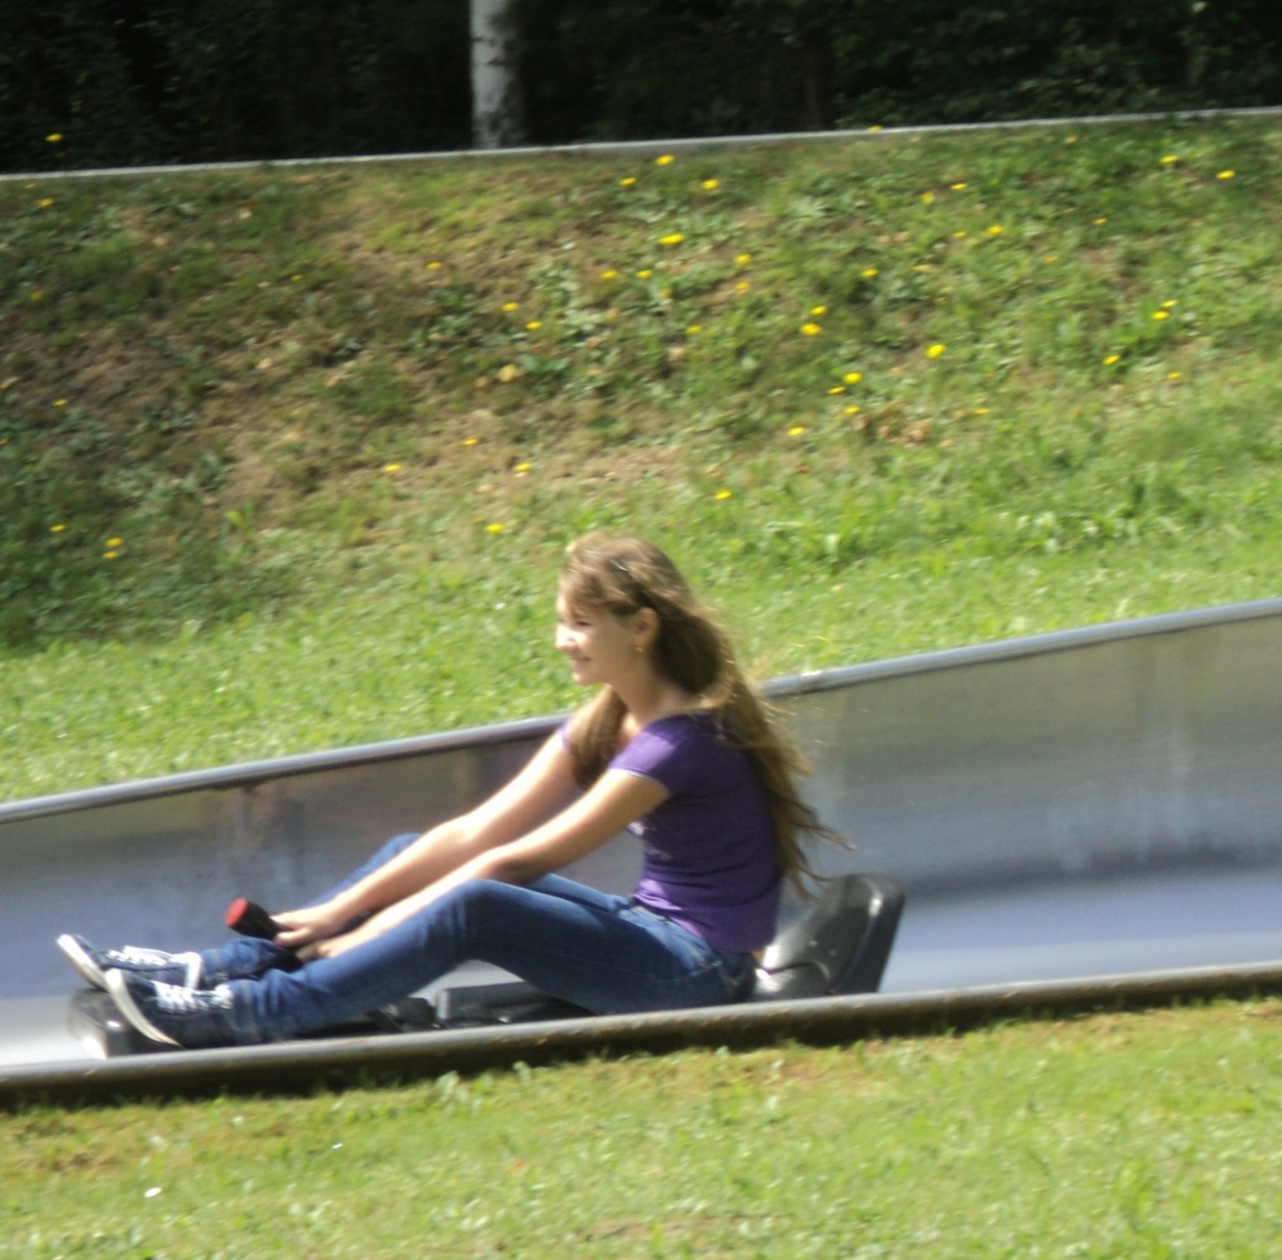

My father and I went fishing. We caught a lot of different fish. 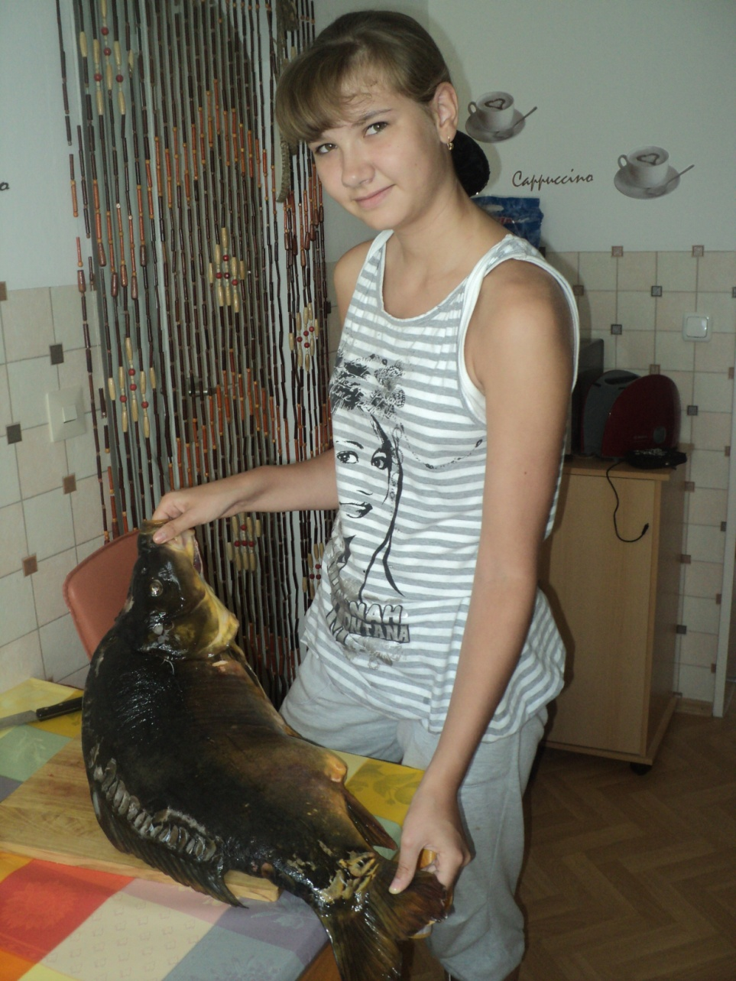



**It appears to me every holiday can be combined with sports. It will be cheerful and useful for health!**



C:\Users\Admin\AppData\Local\Microsoft\Windows\Temporary Internet Files\Content.IE5\6KKJNXMM\MC900432483[1].wmf

**C:\Users\Admin\AppData\Local\Microsoft\Windows\Temporary Internet Files\Content.IE5\KAEDV3L4\MC900416028[1].wmf**

**Thanks for attention!**

C:\Users\Admin\AppData\Local\Microsoft\Windows\Temporary Internet Files\Content.IE5\6KKJNXMM\MC900415938[1].wmf

Фотографии взяты из личного архива с разрешения родителей.

Картинки: <http://images.yandex.kz/yandsearch?text=%D0%BA%D0%B0%D1%80%D1%82%D0%B8%D0%BD%D0%BA%D0%B8%20%D0%BF%D1%80%D0%BE%20%D1%81%D0%BF%D0%BE%D1%80%D1%82%20%D0%B4%D0%BB%D1%8F%20%D0%B4%D0%B5%D1%82%D0%B5%D0%B9&stype=image&lr=10295&noreask=1&source=wiz&uinfo=sw-1663-sh-843-fw-1438-fh-598-pd-1>

<http://images.yandex.kz/yandsearch?text=%D0%BA%D0%B0%D1%80%D1%82%D0%B8%D0%BD%D0%BA%D0%B8%20%D1%81%D0%BC%D0%B0%D0%B9%D0%BB%D0%B8%D0%BA%D0%B8&uinfo=sw-1663-sh-843-fw-1438-fh-598-pd-1>

<http://images.yandex.kz/yandsearch?text=%D0%BA%D0%B0%D1%80%D1%82%D0%B8%D0%BD%D0%BA%D0%B8%20thank%20you&uinfo=sw-1663-sh-843-fw-1438-fh-598-pd-1>