Конкурсная работа

фотоотчёт "Summer – the best time for sport"

Наумова Вероника,

6 класс,
МБОУ - лицей № 4 имени Героя Советского Союза Г. Б. Злотина города Орла.
Учитель: Горинова Светлана Александровна

Hello,
I am the Sun. I like all the people who live on the planet called the Earth, especially the children! They are so smart and funny! They are so creative! More than that, they enjoy various sport activities!
My best friend is Veronica. Once she wrote a letter to me and told me her story…

… Dear Sun,
I’m so happy to have you as a friend! You shine during all the seasons but most of all we get your warmth in summer! We are happy in summer. Summer is full of different activities and it is the best season for sport! Our life is rich in a great number of sports events in summer. That is wonderful! Have a look at my summer activities, read about them and you’ll understand how much we need you.
I like swimming in the pool and in the sea in summer. It’s great!
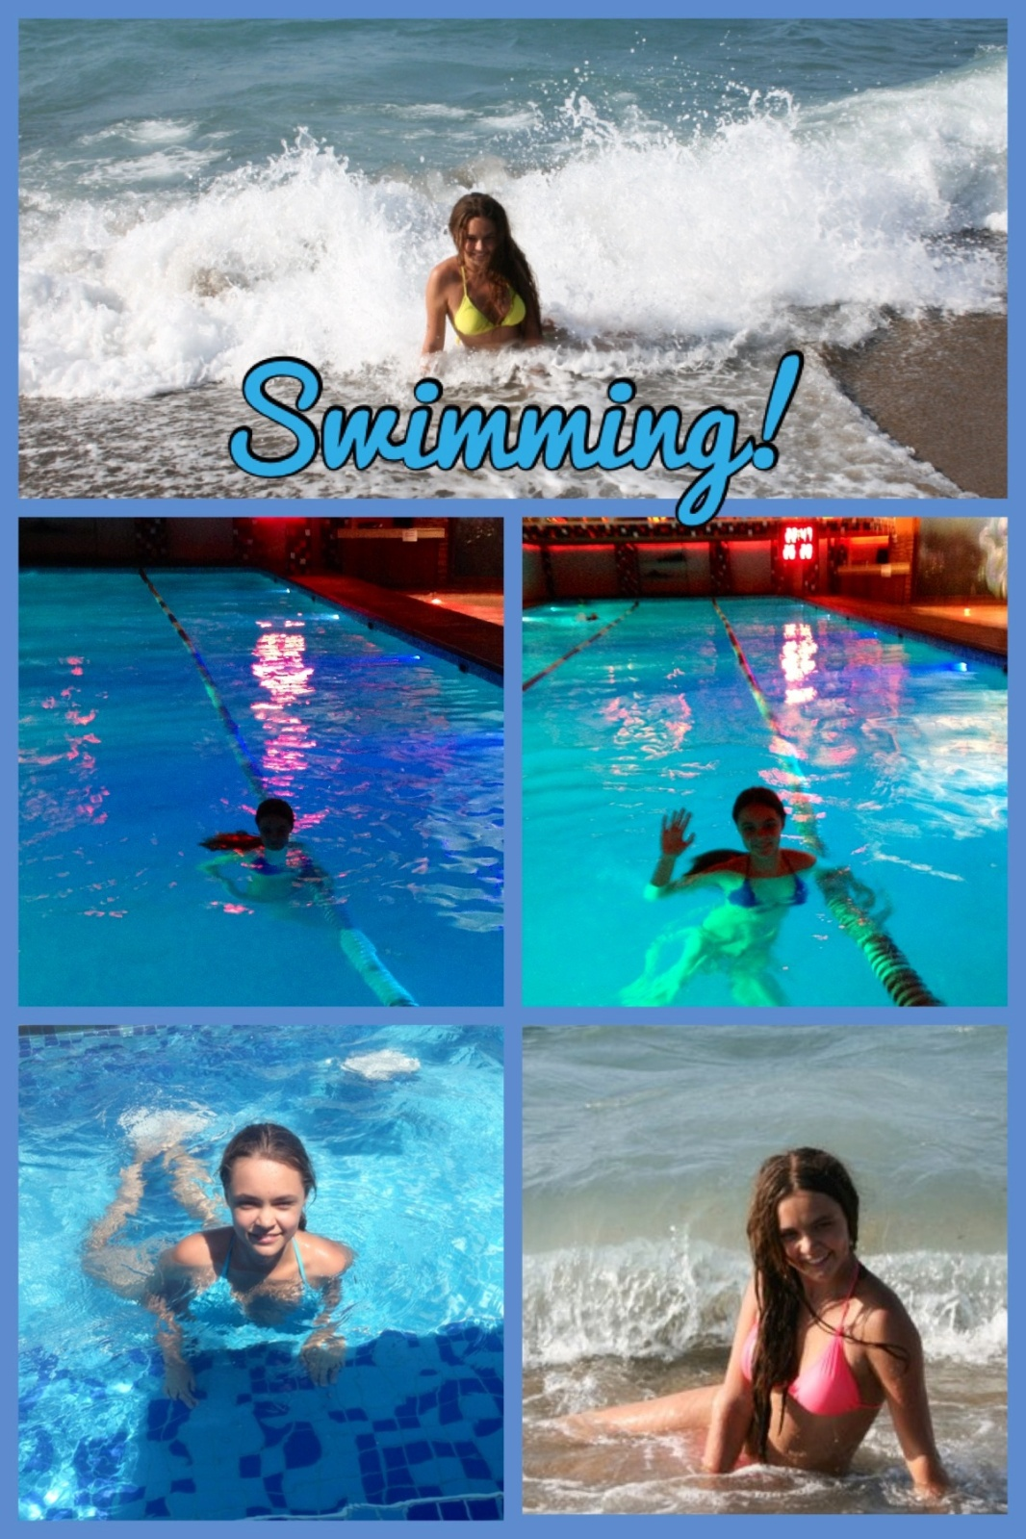
Doing water aerobics is funny! I enjoy doing it greatly!
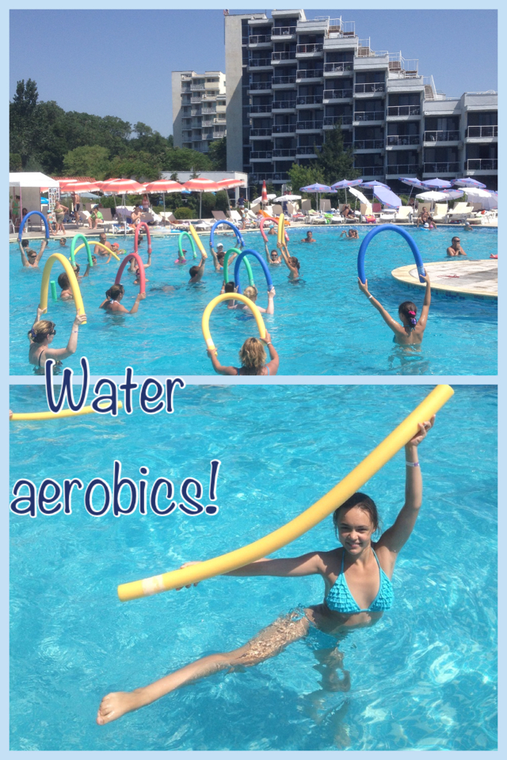

My favorite sport is horse riding! I like horses and I dream to be a great horse rider. You see I’m an experienced rider! I’m not afraid of these animals and we are on friendly terms!

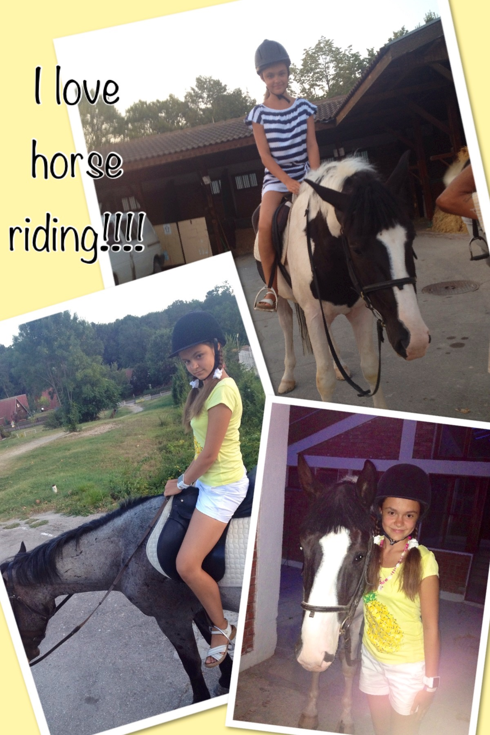
My friends and I like to go to the gym in summer. We usually do it in rainy weather. We play volleyball and basketball and have a good time. As far as you can see, we do it wonderfully!
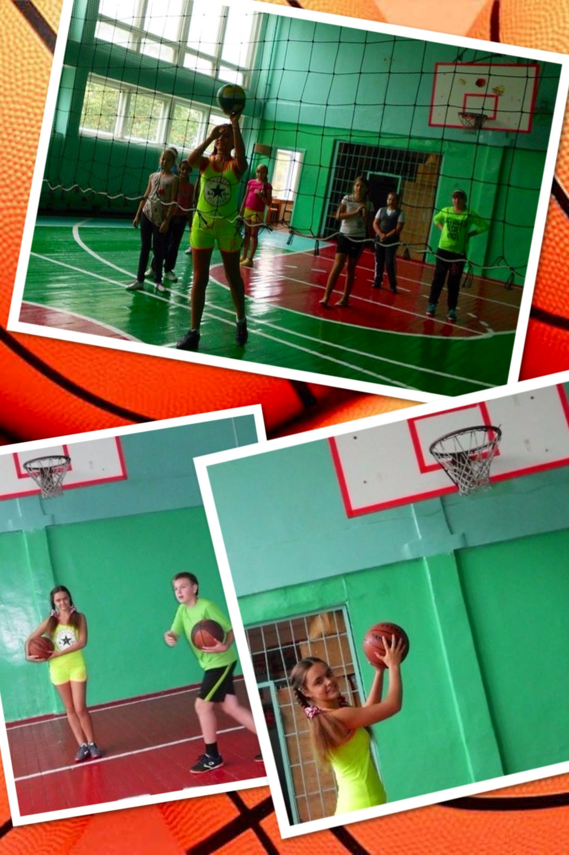
I’m crazy about dancing. In summer our group mates take part in various contests. Usually we have a lot of prizes. We are proud of our brilliant results. That’s terrific!
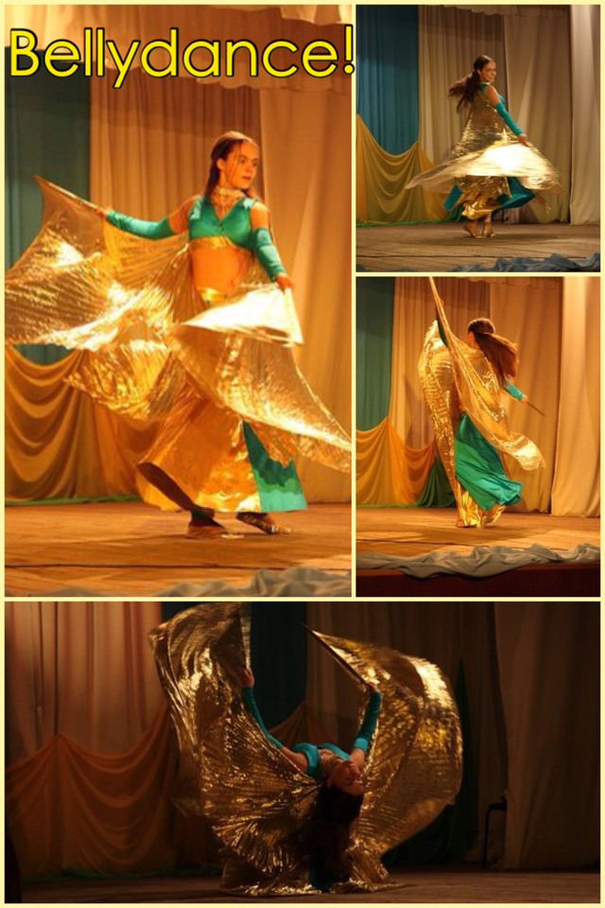
My best friend Solnyshko, as I often call you,
I’d like to show you my respect and love. I kiss and hug you! That is my present for the way you perform your duty. I’m sure you do a good job! You make our summer unforgettable because it is the best time for sport and other activities. It means that you care for us and want us to be healthy and merry!
Thinking of you,
Your Veronica

В своей работе я использовала:
- фотографии, взятые из личного архива семьи Наумовых с разрешения родителей;
- изображения http://images.yandex.ru/
http://images.yandex.ru/yandsearch?source=wiz&uinfo=sw-1263-sh-881-fw-1038-fh-598-pd-1&p=1&text=%D0%BB%D0%B5%D1%82%D0%BE%20%D1%81%D0%BE%D0%BB%D0%BD%D1%8B%D1%88%D0%BA%D0%BE&noreask=1&pos=51&rpt=simage&lr=10&img_url=http%3A%2F%2Fbestsmileys.ru%2Fsunb13007.gi

http://images.yandex.ru/yandsearch?source=wiz&text=%D0%BC%D0%B5%D0%B4%D0%B0%D0%BB%D0%B8&noreask=1&pos=7&rpt=simage&lr=10&uinfo=sw-1263-sh-881-fw-1038-fh-598-pd-1&img_url=http%3A%2F%2Fs39.radikal.ru%2Fi084%2F1004%2F85%2Fcc1fef1d2058.jpg
Boys and girls, I love you! Be happy!

