Конкурс фотоотчётов "Summer – The Best Time For Sport"
  - Вертоголова Ирина Андреевна, 9 класс, МБОУ-лицей №22 г. Орел Учитель: Рябцева Анна Геннадьевна

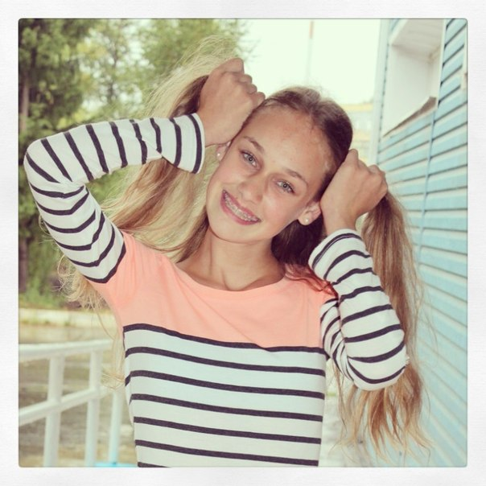
Hello!
My name is Ira.
I am 15 years old.
I live in Orel.
Summer is my favourite season. I like it because it is warm, there is no school and I can do what I want! I did a lot of interesting things this summer. June, July and August were the best time for sport, meeting my friends, reading books and watching films. My summer holidays were great and I like them very much!
Look at my photos!
On the first of June we celebrated Children's Day. My friends and I rode our bikes in the park and had a lot of fun!
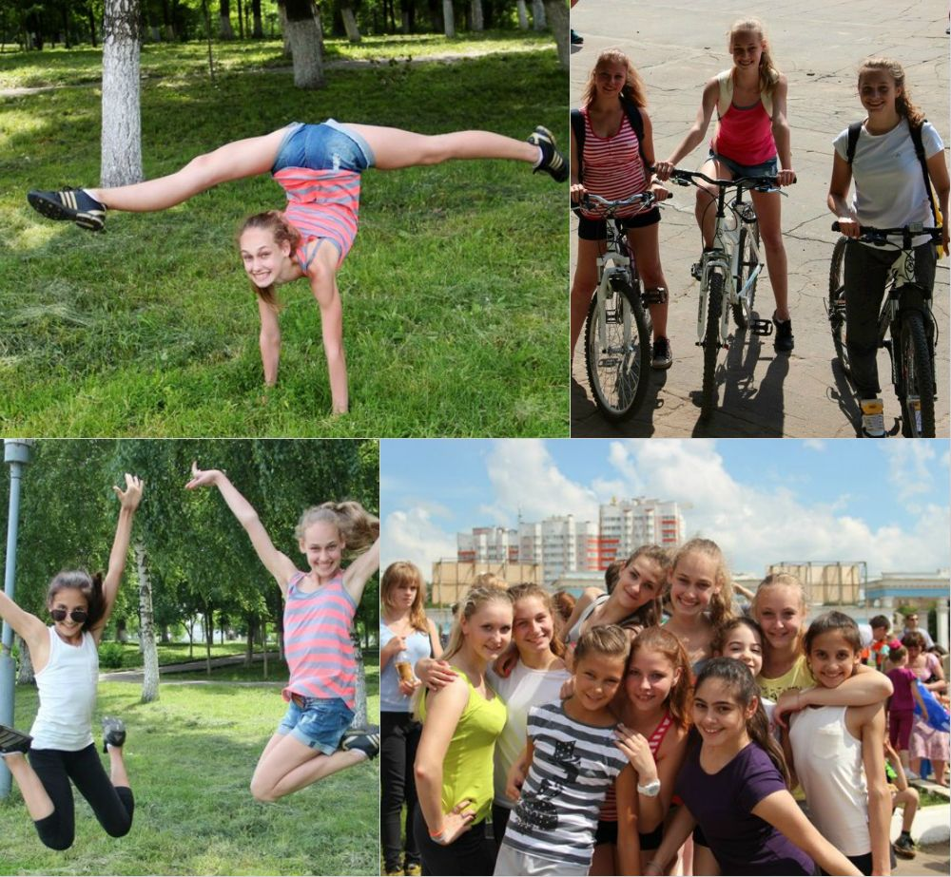

We often cycled to the hippodrome and rode horses.
It was terrific!
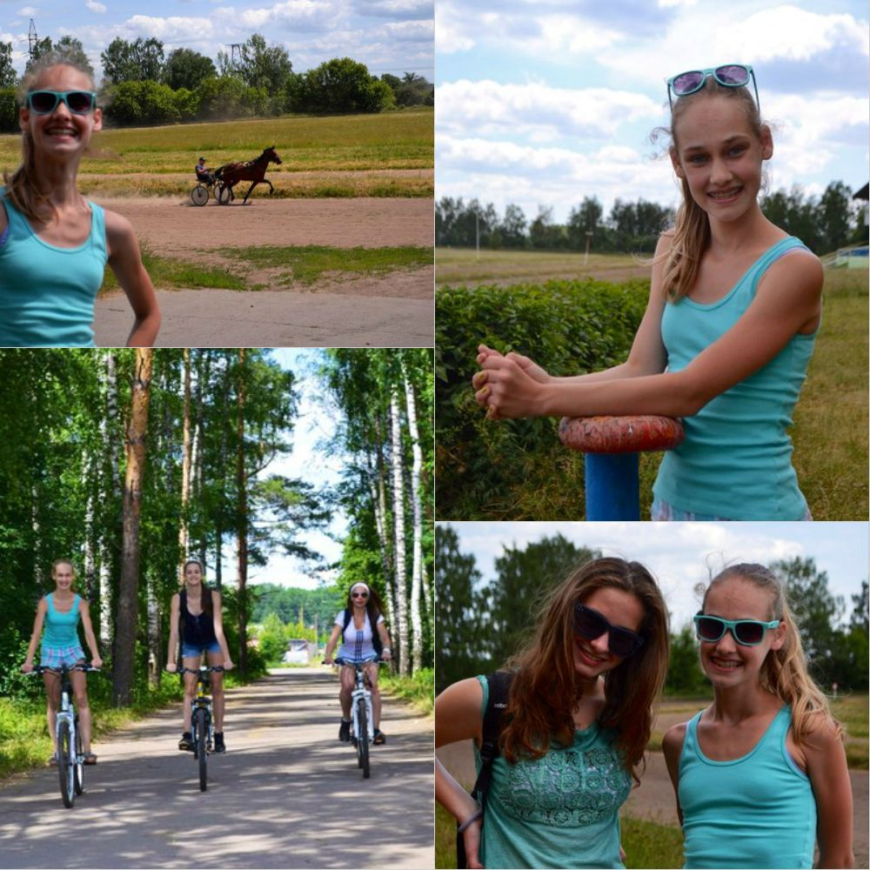

We were on the ropeway. It was dangerous but exciting!
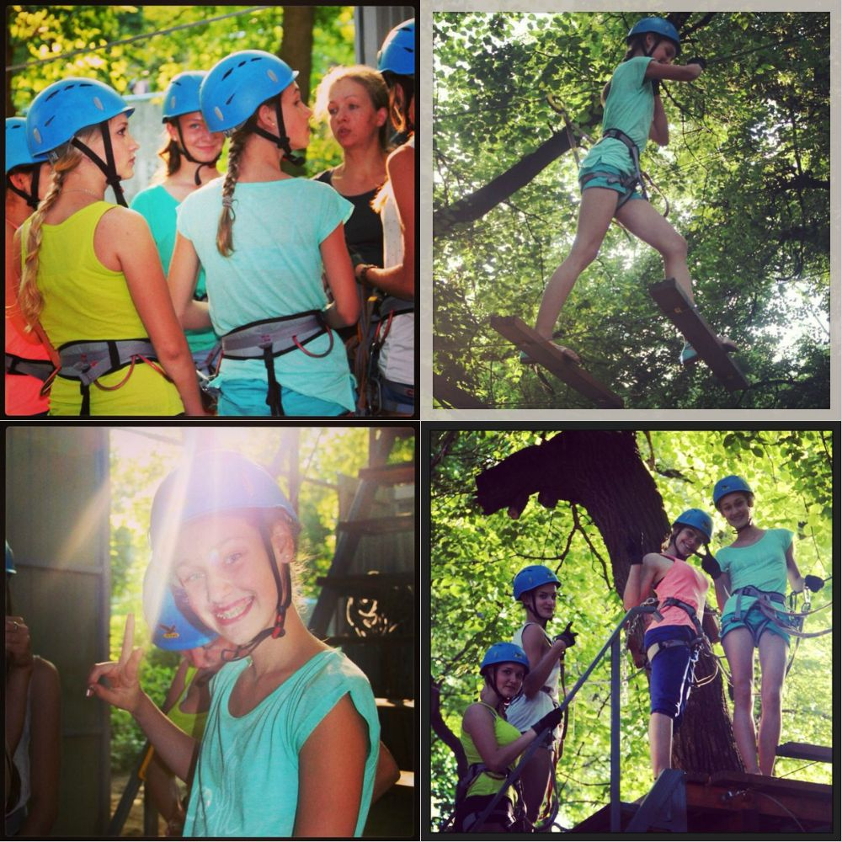

I trained a lot and participated in many contests.

These are my friends! They are very talented and friendly!
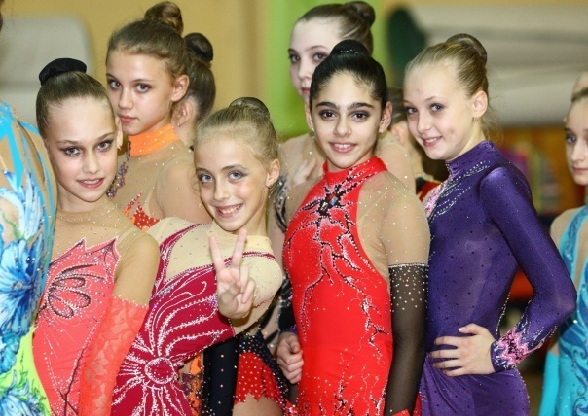

We visited different countries and showed that Russian gymnasts were the best in the world! It was fantastic!
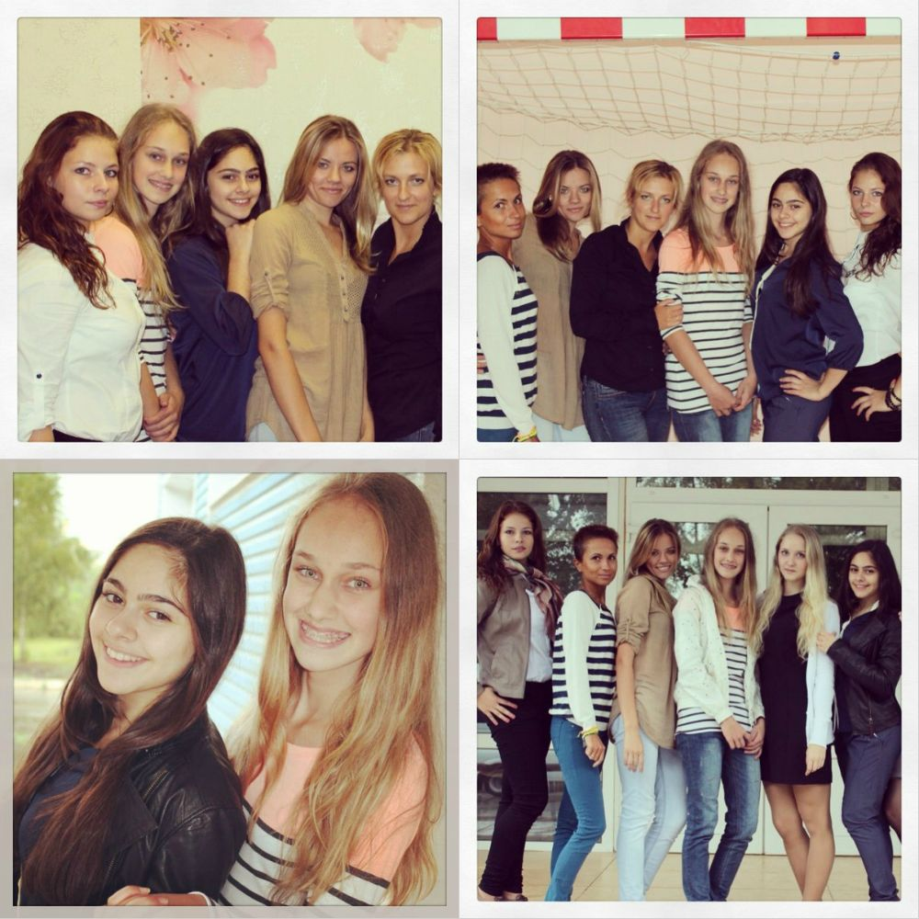

Summer is the best time for swimming! That’s why I swam a lot and played water games.
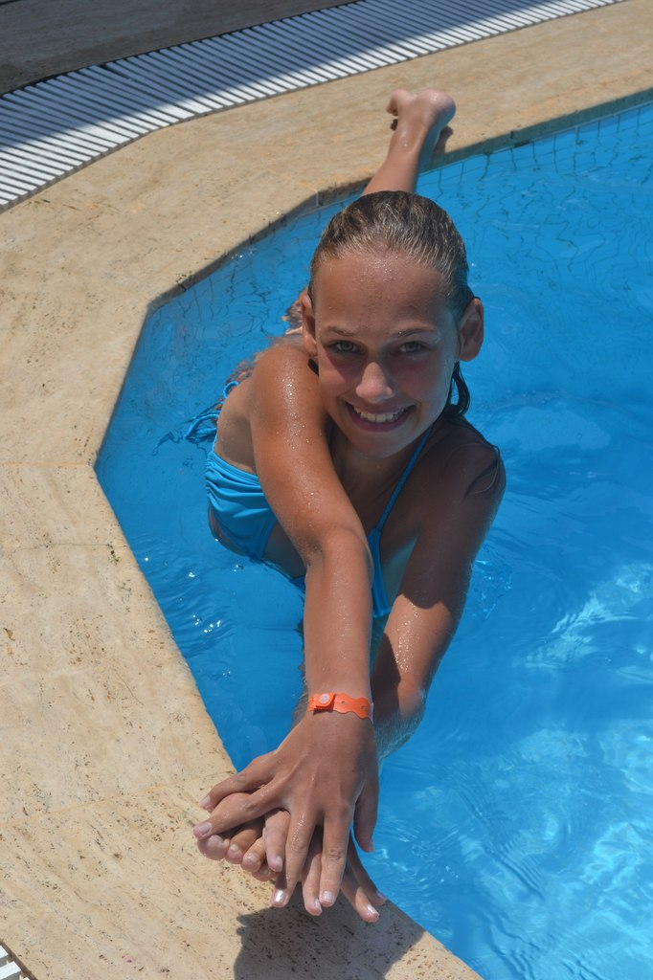
I had a lot of fun!
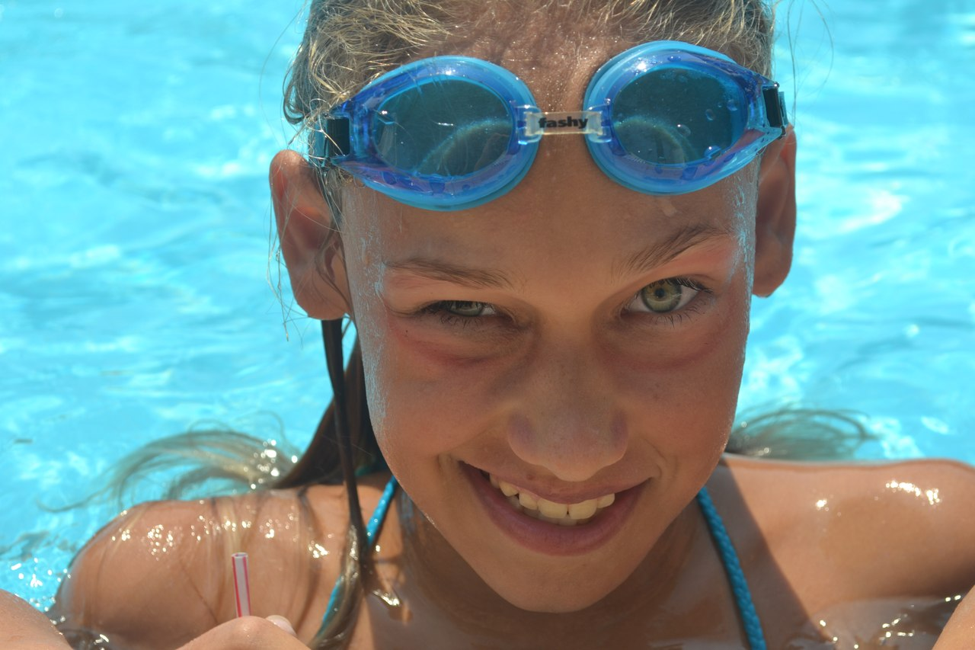
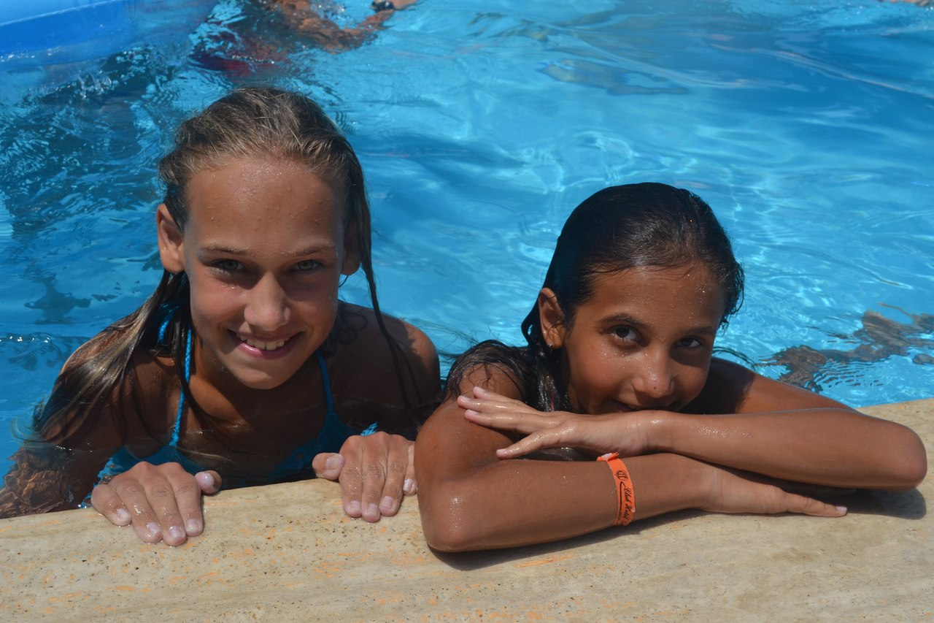
I spent my summer holidays in a good way! And I really believe that summer is the best time for sport and for a good rest!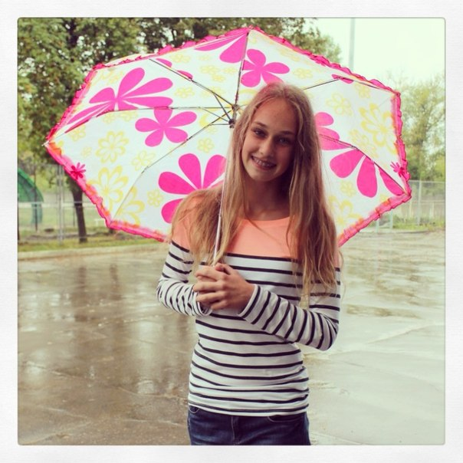

- Фотографии взяты из личного архива с разрешения родителей и лиц присутствующих на фото
- Картинка взята с сайта http://anglyaz.ru/
- Коллажи сделаны с помощью приложения http://vk.com/avatan?mid=96038496&ref=9

