

Кашин Михаил Фёдорович

Ученик 11 класса

МКОУ «Тальменская СОШ №3»

Р.п. Тальменка Алтайский край

Учитель: Таратынова Марина Николаевна

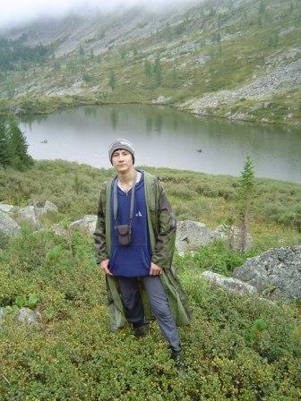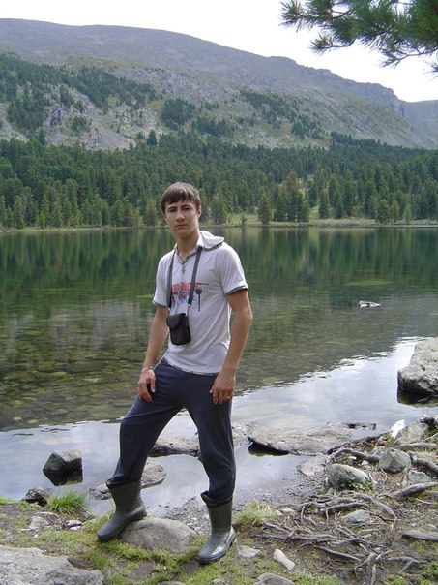Summer is the best time for tourism. Every summer I go to the mountains with my friends.

Gorny Altai is the most wonderful place for it!

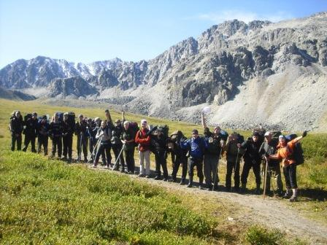

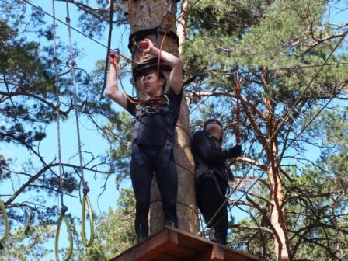

In June I usually take part in the district competitions in tourism between schools.

Usually our school wins.

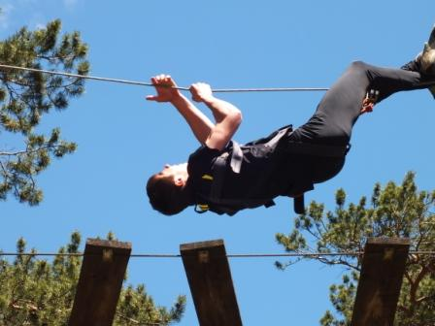

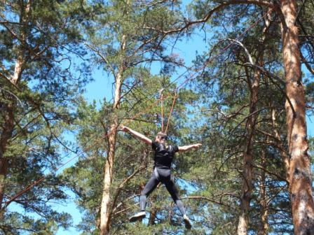

I can do a lot of tricks. I use these abilities when I travel during my holidays in the mountains.

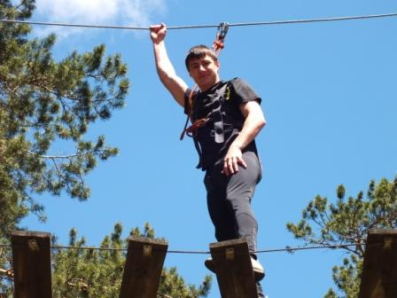

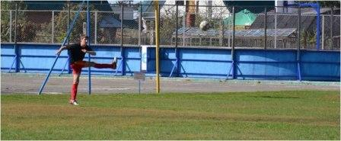

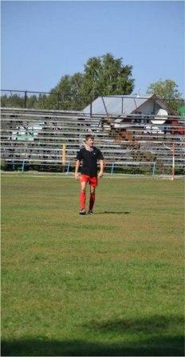

Like many other boys I am fond of playing football. I go to our local stadium if I have a spare minute.

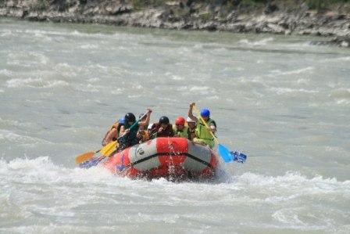

In summer I like to go in for extreme sports.

I travel in a raft. Of course, it’s dangerous, but I am sure that a real man must try it.

In the photo we swim in the Katun, very fast and very cold river in Altai.

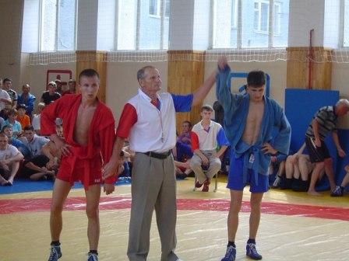

Karate is my favourite kind of sport. I think karate makes me not only strong and healthy, but ahardworking, friendly and ambitious.

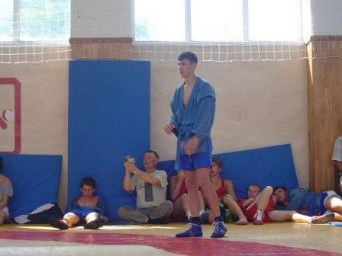

В фотоотчете использованы фотографии из личного архива с разрешения родителей.